Software simulator
The PSU firmware can be also compiled and executed as a Windows, Linux or OS X application. The software simulator is a terminal application that can respond to any currently supported SCPI command described in this document. SCPI commands could be entered directly in the simulator’s terminal window (Fig. 1) or remotely by using the e.g. a Telnet client (Fig. 2).

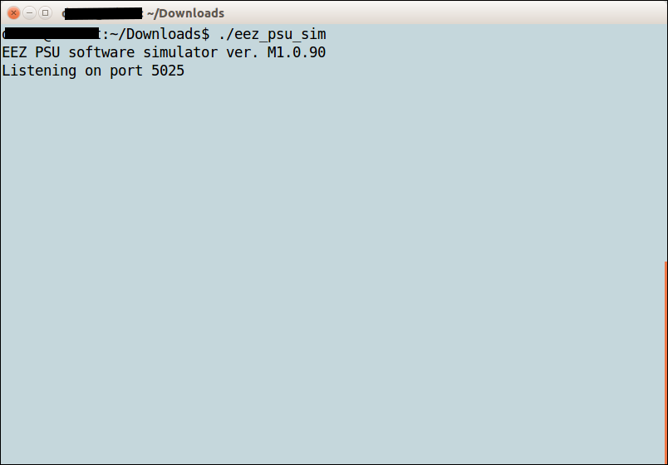Fig. 1: Simulator welcome screen
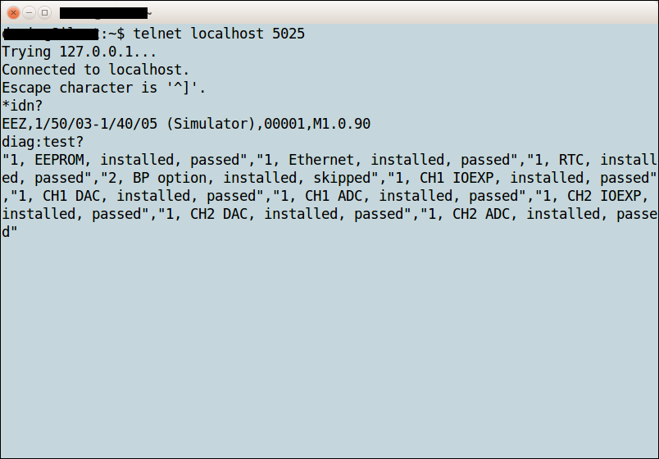Fig. 2: Remote connection using a telnet client
The simulator also has a GUI part when started open a separate window with the picture of the PSU front panel. The GUI depends of what revision is used that can be set in conf_user_revision.h file before simulator compilation.

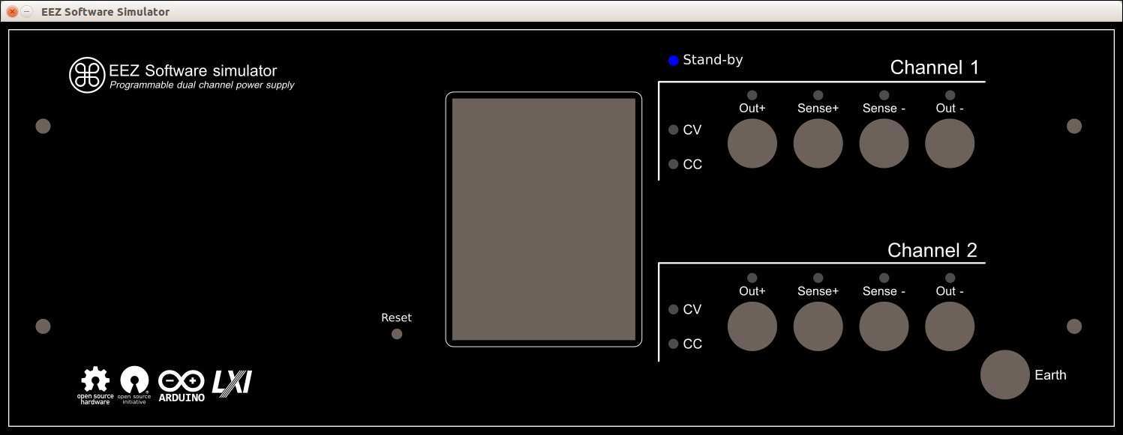Fig. 3: Simulator GUI for portrait front panel (r1B9)

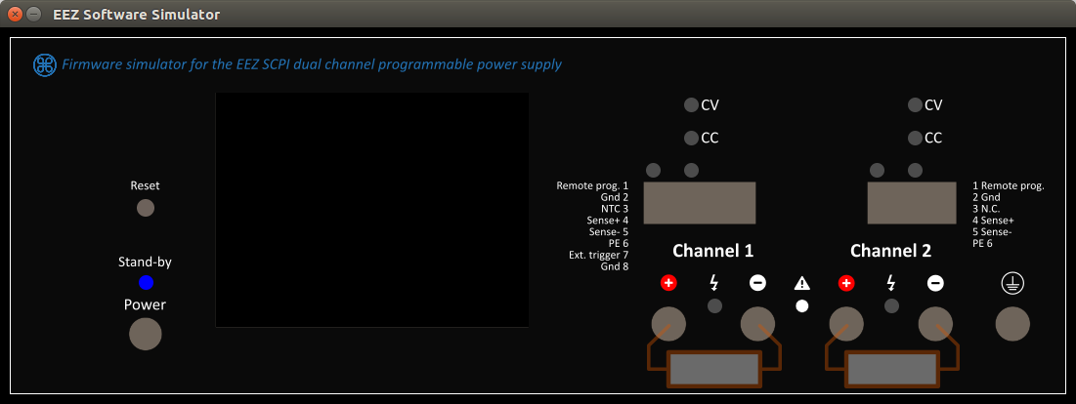Fig. 4: Simulator GUI for landscape front panel (r3B4)
The GUI simulator front panel currently displays only changes in LED indicators and indicates if load is applied on the output terminals or not. For example if 8.2 Ohm load is connected to the channel 2 and cause that channel enters CC mode the GUI front panel will indicate that in the following way:

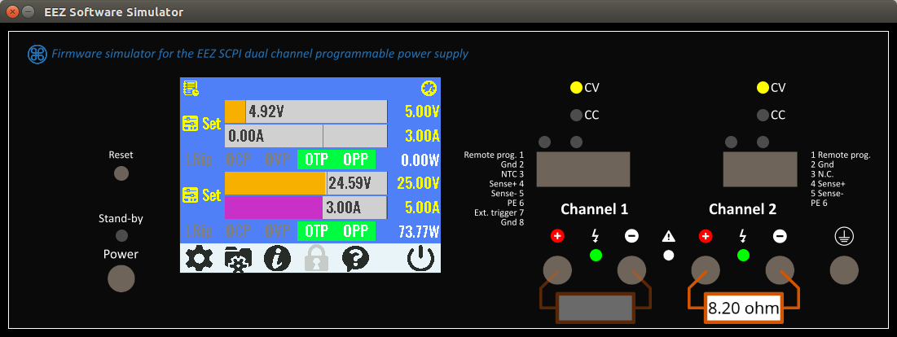Fig. 5: Simulator GUI with connected load on the channel 2

SIMUlator
The SIMUlator subsystem represent a set of unclassified SCPI commands that can be used to manage external parameters and events such as load impedance, connection and disconnection of the load, sensor temperature or the PSU control circuit power supply state. Thanks to them e.g. simulation of the measuring and protection commands that depends of external events become more meaningful.
For example MEASure:CURRent? without connected load will always returns zero, or activation of the VOLTage:PROTection:STATe will automatically trip the OVP since channel cannot starts in CC mode of operation when output is switched on, etc.

SCPI command | Description
SIMUlator
:EXIT | Closes simulator
:GUI | Starts simulator’s GUI
:LOAD {<resistance>} | Sets value of the virtual load
:STATe {<bool>} | “Connects” virtual load to the channel output
:PWRGood {<bool>} | Sets the PWRGOOD signal state
:RPOL {<bool>} | Sets the RPOL signal state
:TEMP {<temperature>} | Sets the temperature sensor value
:VOLT:PROG:EXT {<voltage>} | Sets the output voltage when channel is in external programming mode

SIMUlator:EXIT
Syntax | SIMUlator:EXIT
Description | This command close all Software simulators windows (terminal and GUI if started).
Return | None
Usage example | SIMU:EXIT
Errors
Related Commands

SIMUlator:GUI
Syntax | SIMUlator:GUI
Description | Use this command to start the GUI simulator in the new window (see Fig. 3 and Fig. 4).
Return | None
Usage example | SIMU:GUI
Errors
Related Commands

SIMUlator:LOAD
Syntax | SIMUlator:LOAD {<resistance>}  SIMUlator:LOAD?
Description | This command is used to define impedance of the virtual load that is connected to the channel output. Units are in ohms. With load connected it is possible to simulate e.g. CC mode of operation, current and power measurement, OCP and OPP functionality, etc.  Load value can be also changed by click and drag on the load’s image. Move cursor to the left to decrease, or to the right to increase value in increments of 1 Ω.  The simulator currently cannot emulate the “UR” mode of operation (see the OUTPut:MODE? command).
Parameters | Name | Type | Range | Default
Parameters | <resistance> | Numeric | 0 – 9999999|INFinite | –
Return | The query command returns the programmed load value.
Usage example | SIMU:LOAD 8.2
Errors
Related Commands | OUTPut:MODE?

SIMUlator:LOAD:STATe
Syntax | SIMUlator:LOAD:STATe {<bool>}  SIMUlator:LOAD:STATe?
Description | This command is used to “connect” or “disconnect” the virtual load to the channel output. If the GUI simulator is started (the SIMUlator:GUI command) load symbol with selected value in Ohms will be displayed (See Fig. 5).  Another possibility to connect (or disconnect) a load is by click on its image.
Parameters | Name | Type | Range | Default
Parameters | <bool> | Discrete | ON|OFF|0|1 | –
Return | The query command returns the load state.
Usage example | SIMU:LOAD:STAT?  0  MEAS:CURR?  0.00  SIMU:LOAD:STAT ON  MEAS:CURR?  1.50
Errors
Related Commands | OUTPut:MODE?  SIMUlator:GUI  SIMUlator:LOAD

SIMUlator:PWRGood
Syntax | SIMUlator:PWRGood {<bool>}  SIMUlator:PWRGood?
Description | This command can be used to simulate detection of an internal power supply failure. When PWRGOOD signal is changed from 1 to 0 the PSU is going to the Stand-by mode (equal to the command SYSTem:POW OFF). The PSU mode cannot be changed until PWRGOOD is not changed to 1.
Parameters | Name | Type | Range | Default
Parameters | <bool> | Discrete | ON|OFF|0|1 | ON
Return | The query command returns the PWRGOOD signal state.
Usage example | SYST:POW?  1  SIMU:PWRG 0  SYST:POW?  0
Errors
Related Commands | SYSTem:POWer

SIMUlator:RPOL
Syntax | SIMUlator:RPOL {<bool>}  SIMUlator:RPOL?
Description | This command can be used to simulate detection of remote sensing reverse polarity condition.
Parameters | Name | Type | Range | Default
Parameters | <bool> | Discrete | ON|OFF|0|1 | ON
Return | The query command returns the RPOL signal state.
Usage example | STAT:QUES:INST:ISUM2?  0  SIMU:RPOL 1  STAT:QUES:INST:ISUM2?  128
Errors
Related Commands | [SOURce[<n>]]:VOLTage:SENSe[:SOURce]  STATus:QUEStionable:INSTrument[:EVENt]?

SIMUlator:TEMPerature
Syntax | SIMUlator:TEMPerature {<temperature>}[, {<sensor>}]  SIMUlator:TEMPerature?[ {<sensor>}]
Description | Use this command to set temperature in degrees Celsius (ºC) that will “sense” temperature sensor.
Parameters | Name | Type | Range | Default
Parameters | <temperature> | Numeric | 0 – 100 | –
Parameters | <sensor> | Discrete | MAIN|CH1|CH2 | MAIN
Return | The query command returns the set temperature value.
Usage example | SIMU:TEMP 45, CH2  MEAS:TEMP? CH2  45.00
Errors
Related Commands | MEASure[:SCALar]:TEMPerature[:THERmistor][:DC]

SIMUlator:VOLTage:PROGram:EXTernal
Syntax | SIMUlator:VOLTage:PROGram:EXTernal {<voltage>}  SIMUlator:VOLTage:PROGram:EXTernal?
Description | Use this command to set voltage that will be used for output voltage programming when channel is in external / remote programming mode (see [SOURce[<n>]]:VOLTage:PROGram[:SOURce]). For full range apply 2.5 V and if higher value is entered channel’s OVP will trip.
Parameters | Name | Type | Range | Default
Parameters | <voltage> | Numeric | Positive value | 0.00
Return | The query command returns the external output voltage programming value.
Usage example | VOLT:PROG EXT  SIMU:VOLT:PROG:EXT 1.25  MEAS?  20.00
Errors
Related Commands | [SOURce[<n>]]:VOLTage:PROGram[:SOURce]  [SOURce[<n>]]:VOLTage:PROTection:TRIPped?

